Glen Iris Primary School

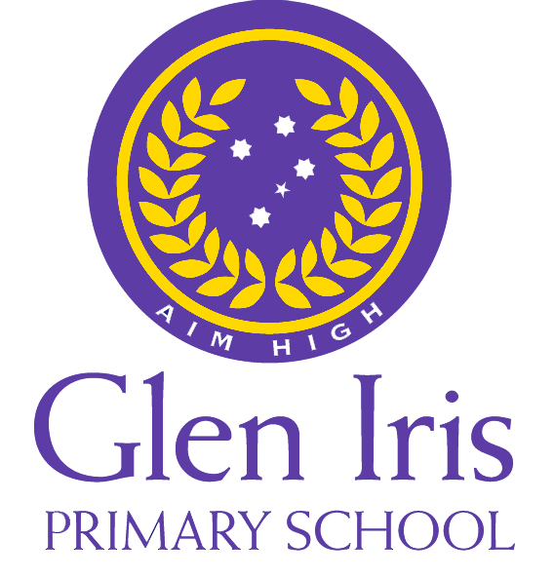

170 Glen Iris Rd, Glen Iris, Vic, 3146

18 November 2025

Dear Parents and Carers,

Glen Iris Primary School is looking forward to another great year of teaching and learning and would like to advise you of Glen Iris Primary School’s parent payment financial contributions for **2025.**

Schools provide students with fee free instruction to fulfil the standard Victorian curriculum, and we want to assure you that all contributions are voluntary. Nevertheless, the ongoing support of our families ensures that our school can offer the best possible education and support for our students. We want to thank you for your support, whether that’s through fundraising or volunteering your time. This has made a difference to our school and the programs we can offer.

The contributions we are requesting will allow us to resource our classrooms; upgrade our classroom furniture; help maintain our library; ensure we have the best apps and subscriptions for student learning; and resource our wellbeing program.

For further information on the Department’s Parent Payments Policy, please see a one-page overview included.

Yours sincerely,

Maddie Witter

Principal

Kirsty Watts

School Council President

Glen Iris小学期待着在新的一年里继续提供卓越的教学，并在此通知您2025年的家长缴费捐助相关事项。

学校将为学生提供免费的课程，以满足维州的标准课程要求，我们也向您保证，所有捐助的费用均以自愿为准。然而，家长们的持续支持确保了学校能为学生提供更优质的教育和支持。无论是通过募款还是志愿服务，我们都非常感谢您的支持，这将对学校及其所提供的课程产生积极的影响。

我们收到的捐助将用于教室资源的补充、课桌椅的更新、图书馆的维护，确保学生在学习中使用最好的应用程序和资源订阅，以及用于我们的心理健康项目资源的投入。

如需了解更多关于教育部家长缴费政策的信息，请参阅附上的概览页。

此致

敬礼

Maddie Witter

校长

Kirsty Watts  
 学校理事会主席

**For our Year Four Classrooms**

| Curriculum Contributions- items that students use, or participate in, to access the curriculum  Financial contributions for curriculum items and activities which the school deems necessary for students to learn the Curriculum. | Amount |
| --- | --- |
| **General and specialist classroom materials and equipment**   * Classroom supplies- exercise books, scrap books, pens, pencils, poster paints, crayons, coloured paper, general classroom supplies ($90) * Visual Art supplies ($12) * STEM Design Learning Supplies ($8) * Performing Art Supplies ($2) * Physical Education Supplies ($2) * Spanish Supplies ($5) | $119 |
| **Digital and Online Subscriptions for Learning:**   * Seesaw ($12) * Mathletics ($16.50) * Storybox Library ($2) * Sound Waves ($17.50) * Maths Online ($18.50) | $66.50 |
| **Printed Learning Resources** | $17 |
| **Student diary** | $10 |
| **Provision and upkeep of shared school devices, projectors, teaching screens, and ICT:** | $20 |
| Other Contributions- for non-curriculum items and activities  Financial contributions for non-curriculum items and activities that relate to the school’s functions and objectives. | Amount |
| Enhanced wellbeing supports | $50 |
| Office administration (includes communication tools, first aid, and hygiene costs) | $55 |
| Grounds and Maintenance | $59 |
| Total (Curriculum and Other Contributions) | $396.50 |
| Tax Deductible contributions | Amount |
| Building Fund- A tax deductible contribution (depending on your circumstance) to support renovations, upgrades, and maintenance of the school infrastructure | $100 |
| Library Fund- A tax deductible contribution (depending on your circumstances) to support book purchases and other equipment that will sustain the library as a valuable resource | $200 |
| Total (Curriculum, Other, and Tax Deductible Contributions) | $696.50 |

**Payment methods**

Glen Iris Primary School’s preferred payment method is Via Compass Parent Payment Portal, and payments can be made starting today. For your convenience we have also set up a payment plan option which allows you to pay in set instalments over Terms 1 & 2 2025. Please contact David who can support you should you wish to arrange a different payment plan that suits your circumstances.

**Financial support for families**

Glen Iris Primary School understands that some families may experience financial difficulty and offers a range of support options including:

* the Camps, Sports and Excursions Fund
* State Schools Relief (SSR)

For a confidential discussion about accessing these services, or if you would like to discuss alternative payment arrangements, contact:

David Patmore

Acting Business Manager

Ph: 03 9885 3624 Email: david.patmore@education.vic.gov.au

**For our Year Four Classrooms**

| 课程捐助 —— 学生使用或参与的课程相关物品  为课程物品和活动提供的财务捐助，这些物品和活动是学 | Amount |
| --- | --- |
| **General and specialist classroom materials and equipment**  通用和专业教室材料及设备：   * 教室用品：练习本、剪贴簿、笔、铅笔、海报颜料、蜡笔、彩纸、通用教室用品（$90） * 视觉艺术用品（$12） * STEM设计学习用品（$8） * 表演艺术用品（$2） * 体育用品（$2） * 西班牙语用品（$5） | $119 |
| 数字化学习用的一些应用程序和在线订阅的一些资料：   * Seesaw ($12) * Mathletics ($16.50) * Storybox Library ($2) * Sound Waves ($17.50) * Maths Online ($18.50) | $66.50 |
| 打印的学习资源 | $17 |
| **Student diary** | $10 |
| 共享学校设备、投影仪、教学屏幕和信息技术设备的提供和维护 | $20 |
| 其他捐款-用于非课程项目和活动  用于与学校职能和目标相关的非课程项目和活动的财政捐款 | Amount |
| 加强心理健康和支持 | $50 |
| 办公室行政开销（包括通讯工具、急救和卫生费用） | $55 |
| 场地和维护 | $59 |
| 合计（课程和其他非课程捐助） | $396.50 |
| Tax Deductible contributions | Amount |
| 建筑基金 - 可抵税捐款（根据您的具体情况），用于支持学校基础设施的翻修、升级和维护。 | $100 |
| 图书馆基金 - 可抵税捐款（根据您的具体情况），用于支持书籍购买和其他设备，以维持图书馆作为宝贵资源的功能。 | $200 |
| 合计（课程捐助，其他以及可抵税捐助） | $696.50 |

**付款方式** Glen-Iris小学首选的付款方式是通过Compass家长支付门户，您可以从今天开始进行支付。为了方便您的支付，我们还提供了分期付款选项，您可以在2025年第一学期和第二学期分期支付。如果您希望安排更适合您情况的付款方式，请联系David，我们将为您提供支持。

**家庭财务支持** Glen-Iris小学理解一些家庭可能会面临经济困难，并提供一系列支持选项，包括：

l 户外营地活动、支持和校外活动基金

l 州立学校援助（SSR）

关于如何使用这些服务或其他一些需要保密的讨论，请联系：  
 David Patmore

业务执行经理

电话：03 9885 3624 电子邮件: David.patmore@education.vic.gov.au